## A REPORT

## ON

## The Digital Network for Verified Property Transactions

***Submitted by,***

# Abdul Majeed 20211ISE0014 Pruthvi Bhat 20211ISE0019 Hatti Vishnu 20211ISE0037

### *Under the guidance of,*

**Dr. G.Shanmugarathinam**

***in partial fulfillment for the award of the degree of***

**BACHELOR OF TECHNOLOGY**

**IN**

**INFORMATION SCIENCE AND ENGINEERING**

**At**



**PRESIDENCY UNIVERSITY**

**BENGALURU**

**MAY 2025**

**PRESIDENCY UNIVERSITY**

**PRESIDENCY SCHOOL OF COMPUTER SCIENCE AND ENGINEERING**

**CERTIFICATE**

This is to certify that the Internship/Project report **“The Digital Network for Verified Property Transactions”** being submitted by “ABDUL MAJEED, PRUTHVI BHAT, HATTI VISHNU” bearing roll number “20211ISE0014, 20211ISE0019, 20211ISE0037” in partial fulfillment of the requirement for the award of the degree of Bachelor of Technology in Information Science and Engineering is a bonafide work carried out under my supervision.

|  |  |
| --- | --- |
| **Dr.G.Shanmugarathinam**  **Professor**  PSCS / PSIS  Presidency University | **Dr. Pallavi R**  Professor & HoD  PSCS  Presidency University |

|  |  |
| --- | --- |
| **Dr. MYDHILI NAIR**  Associate Dean  PSCS  Presidency University | **Dr. SAMEERUDDIN KHAN**  Pro-Vice Chancellor - Engineering  Dean –PSCS / PSIS  Presidency University |

**PRESIDENCY UNIVERSITY**

**PRESIDENCY SCHOOL OF COMPUTER SCIENCE AND ENGINEERING**

**DECLARATION**

I hereby declare that the work, which is being presented in the report entitled “**The Digital Network for Verified Property Transactions”** in partial fulfillment for the award of Degree of **Bachelor of Technology** in Information Science and Engineering, is a record of my own investigations carried under the guidance of **Dr.G.Shanmugarathinam, Professor,** **Presidency School of Computer Science and Engineering, Presidency University, Bengaluru.**

I have not submitted the matter presented in this report anywhere for the award of any other Degree.

|  |  |  |
| --- | --- | --- |
| **Student Name** | **Roll Number** | **Signature** |
| **Abdul Majeed** | **20211ISE0014** |  |
| **Pruthvi Bhat** | **20211ISE0019** |  |
| **Hatti Vishnu** | **20211ISE0037** |  |

**ABSTRACT**

The Indian real estate industry has been suffering from serious issues like absence of transparency, rampant fraud, sluggish and cumbersome transactions, and disjointed digital services for a long time. To address these problems, this platform has been envisioned as an all-encompassing, end-to-end digital solution aimed at transforming the way property transactions are carried out in the country.

This cutting-edge platform is made to act as a single, integrated ecosystem that brings together all the major players in the property sector, namely buyers, sellers, real estate agents, legal advisors, and financial institutions. Through a single interface, the platform streamlines each phase of the property transaction process, ranging from discovery and assessment to negotiation, documentation, and ultimate registration.

One of the key pillars of this solution is the provision of verified property data. Property listings are thoroughly authenticated through integrated access to government land and property registration databases, which makes them accurate and legitimate. This minimizes the risk of fraudulent listings and provides peace of mind to potential buyers and sellers.

Another most important feature of the platform is the incorporation of cutting-edge technologies, including AI-based algorithms, to provide users with customized property suggestions according to user interest, search history, budget, and location preferences. These smart search and suggestion engines enhance user interaction and enable quicker and more relevant property discovery.

To further streamline the buying and selling process, the platform also automates most of the otherwise manually labor-intensive and error-prone steps involved in property transactions. These include auto-filling necessary legal documents, checklists of documents, and enabling online submission for quick turnaround times. Communication tools built-in enable effortless communication between interested parties, ranging from scheduling property tours, negotiation, and trading important documents all in a secure setting.

The platform also supports features like mortgage and affordability calculators, location-based market analysis, and trend analytics to enable decision-making through data. Whether the buyer wants to compare loans or the seller needs to evaluate price trends in a local area, the platform provides real-time actionable insights.

Security and data integrity are of the utmost importance. The platform integrates strong access controls, end-to-end encryption, multi-factor authentication, and secure payment processing using trusted gateways such as Stripe. These aspects guarantee that user data, individual information, and financial transactions are processed with utmost levels of confidentiality and protection.

Technologically, the solution is developed with contemporary, scalable frameworks and tools. The front-end development is done in React and Tailwind CSS to provide a quick, responsive, and visually appealing user interface. The back-end infrastructure is powered by Node.js and MongoDB for high performance, real-time data updates, and scalable data handling. Stripe handles and secures all financial transactions for smooth money handling by users.

The project undergoes a phased development life cycle to maintain quality, agility, and flexibility. It starts with an extensive research and requirement analysis phase, wherein market requirements, regulatory limitations, and user expectations are extensively analyzed. This is followed by system design and architecture planning, iterative development, extensive testing (functional and non-functional), deployment, and ongoing post-launch monitoring and updates.

This platform is more than an online property marketplace—it is being designed as an all-encompassing ecosystem that empowers customers to make clear, well-informed, and safe property choices. With the aid of technological advancements, automation, and consumer-centric design, the platform is geared towards making India's real estate experience newer, better, more transparent, more efficient, and accessible to all.

**ACKNOWLEDGEMENTS**

First of all, we indebted to the **GOD ALMIGHTY** for giving me an opportunity to excel in our efforts to complete this project on time.

We express our sincere thanks to our respected dean **Dr. Md. Sameeruddin Khan**, Pro-VC - Engineering and Dean, Presiency School of Computer Science and Engineering & Presiency School of Information Science, Presidency University for getting us permission to undergo the project.

We express our heartfelt gratitude to our beloved Associate Dean **Dr. Mydhili Nair,** Presidency School of Computer Science and Engineering, Presidency University, and Dr. Pallavi R, Head of the Department, Presidency School of Computer Science and Engineering, Presidency University, for rendering timely help in completing this project successfully.

We are greatly indebted to our guide **Dr.G.Shanmugarathinam Professor** and Reviewer **Ms. Sunitha BJ, Assistant Professor**, Presidency School of Computer Science and Engineering, Presidency University for their inspirational guidance, and valuable suggestions and for providing us a chance to express our technical capabilities in every respect for the completion of the internship work.

We would like to convey our gratitude and heartfelt thanks to the CSE7301 University Project Coordinator **Mr. Md Ziaur Rahman and Dr. Sampath A K,** department Project Coordinators **Mr. Srinivas Mishra** and Git hub coordinator **Mr. Muthuraj.**

We thank our family and friends for the strong support and inspiration they have provided us in bringing out this project.

**Abdul Majeed**

**Pruthvi Bhat**

**Hatti Vishnu**

**LIST OF FIGURES**

Sl. No. Figure Name Caption Page No.

1 Fig 4.1 Data Flow 18

2 Fig 7.1 Gantt Chart 23

**LIST OF ABBREVIATIONS**

**ABBREVIATIONS EXPANSIONS**

**DLS** Deep Learning System

**AI** Artificial Intelligence

**CNN** Convolutional Neural Network

**ML**  Machine Learning

**YOLO** You Only Look Once

**SSD**  Single Shot MultiBox Detector

**IoU** Intersection over Union

**TP** True Positive

**FP** False Positive

**FN** False Negative

**TABLE OF CONTENTS**

|  |  |  |
| --- | --- | --- |
| **Chapter No.** | **Title** | **Page No.** |
| **—** | **Abstract** | **i** |
| **—** | **Acknowledgment** | **ii** |
| **1** | **Introduction** | **1** |
| **1.1** | **Background** | **1** |
| **1.2** | **Problem Statement** | **2** |
| **1.3** | **Objective and Scope** | **13** |
| **1.4** | **Significance** | **15** |
| **1.5** | **Industry Context** | **—** |
| **2** | **Literature Survey** | **16** |
| **2.1** | **Overview** | **17** |
| **2.2** | **Observations** | **19–21** |
| **3** | **Advantages and Disadvantages of Existing Platforms** | **~22** |
| **4** | **Proposed Methodology** | **~30** |
| **5** | **Objectives** | **~36** |
| **6** | **System Design & Implementation** | **~41** |
| **7** | **Timeline for Execution of Project (Gantt Chart)** | **~44** |
| **8** | **Expected Outcomes** | **~45** |
| **9** | **Features** | **~52** |
| **10** | **Results and Discussions** | **~59** |
| **11** | **Conclusion** | **~62** |
| **—** | **References** | **~64** |
| **Appendix A** | **Pseudocode** | **~66** |
| **Appendix B** | **Screenshots** | **~67** |
| **Appendix C** | **Enclosures** | **~68** |

**Chapter 01**

**INTRODUCTION**

1.1 Background

India's real estate industry is among the country's most decisive supports of the nation's economy and contributes considerably, not only towards the growth in infrastructure development, but also significantly towards Gross Domestic Product (GDP) growth and even larger-scale employment generation. With the nation facing fast-paced urbanization and industrialization, the demand for housing, commercial, and industrial property has increased immensely over the last few years. Urban migration, an increasing number of middle-class individuals, and a high desire to own assets have further accelerated the demand for housing and real estate investment assets in metropolitan cities, tier-two towns, and even semi-urban regions.

India's real estate sector is also undergoing structural changes fueled by demographic changes, rising disposable incomes, lifestyle changes, and policy changes. Government programs like "Housing for All," the launch of the Real Estate (Regulation and Development) Act (RERA), and the digital India push have all helped formalize and partially modernize the industry. But despite these encouraging signs and prospects, the real estate sector remains bedeviled by a host of entrenched and longstanding issues that slow its growth, effectiveness, and legitimacy.

Chief among these is the process of real estate transactions, which remain notoriously complicated and hard to handle. Transactions are often accompanied by a maze of bureaucratic processes that include multiple steps like title authentication, paperwork, registration, and taxation. Every one of these procedures often involves interactions with numerous middlemen—like brokers, law consultants, government agencies, and financial institutions—adding levels of interdependence and prolonging the time and expense involved in the transfer of properties. These inefficiencies cause significant delays and are a vexatious process for both sellers and buyers.

Additionally, the ongoing use of manual, paper-based recordation and verification systems exposes real estate transactions to manipulation, misinformation, and inaccuracies. Property documents like ownership records, tax receipts, encumbrance certificates, and registration papers are usually kept physically, which makes them prone to loss, forgery, and alteration. The lack of a single, digitally searchable database of authenticated property records makes the due diligence process even more difficult, as stakeholders must go through lengthy processes to cross-check the validity of every document.

The absence of uniformity and standardization in processes from one region or state to another in India aggravates the situation further. Property laws, registration procedures, stamp duty frameworks, and data structures can differ in each state, making inter-state property transfers even more tedious and inconsistent. Fragmented operations, legal complexities, and regular misunderstandings among the stakeholders arise from the lack of a single platform or process.

Another important issue is the general absence of transparency in property dealings. It is usually hard for potential buyers to get verified and recent information on the legal status of a property, previous ownership records, or pending legal conflicts. This lack of transparency encourages a culture of mistrust and rumor, with buyers having to heavily depend on brokers and unofficial channels that can provide or not provide correct information. Consequently, property transactions are usually filled with fear, uncertainty, and risk of financial loss through fraud or misrepresentation.

1.2 Problem Statement

The conventional real estate model suffers from some well-established problems. Forgery of documents is an endemic issue because scammers can easily tamper with property deeds, ownership titles, and other official documents. This leads to litigation, causes economic loss, and results in drawn-out cases in court for unwitting buyers or investors.

Another key concern is the delay in government verification and registration processes. Most property transactions are delayed because of manual paperwork, non-digital connectivity with public records, and archaic administrative processes. This creates bottlenecks that discourage prompt property transfers and render the system inefficient.

Apart from delays and fraud, the lack of a uniform pricing mechanism throughout the market is also responsible for opaque valuation practices. The buyers tend to be deprived of sound market information, leading to a gap between the quoted price and the actual value of properties. This transparency issue prevents customers from making informed choices and further undermines confidence in the system.

Finally, the scattered nature of real estate websites adds to the complexity. Consumers often rely on isolated tools for searching properties, communicating, legal advising, and handling payments. Such a fractured experience causes disorientation, less efficiency, and heightened chances of error.

Such crucial information as historical ownership data, outstanding court litigations, property tax information, and land use categorization is generally not readily available or compiled at a single point. This absence of centralized and verified information makes it hard for buyers to carry out proper due diligence, particularly in large transactions. Consequently, potential homeowners and investors have to rely greatly on brokers, who might not always have their best interest at heart. The lack of a reliable and transparent information system creates an environment wherein misinformation can be fueled and amounts to a significant risk to what is otherwise usually one of the biggest financial decisions a person will ever make.

Secondly, the slow uptake of new technologies in real estate services has held back the formation of a seamless and user-driven experience. In a world where most businesses have adopted automation, AI-driven intelligence, and digital connectivity, the real estate industry still largely depends on old-fashioned manual workflows. Not only does this decelerate business but also inhibit scalability, cap personalization, and drive overhead expenses for service providers. Customers increasingly demand seamless interfaces, live updates, and efficient workflows—demands rarely fulfilled by current platforms. The absence of integration and innovation in conventional real estate systems has created a segmented, ineffective ecosystem that desperately needs to get modernized to address modern user demands and sector standards.

1.3 Objective and Scope

The core goal of this project is to create a safe, user-friendly, and transparent digital platform for Indian real estate transactions. The platform aims to resolve the most significant inefficiencies of the existing system by making the entire transaction process—from listing to closure—smooth within a single digital framework.

The platform will enable users to list, search, compare, and discover properties according to their particular requirements and preferences. Buyers and sellers will be able to directly communicate with confirmed agents and service providers. Notably, the platform will connect to government APIs to enable real-time document authentication and status checking, thereby reducing the scope for fraudulent activities and ensuring property documents are authentic, updated, and legally valid.

Moreover, the platform will have mandatory features like user dashboards, secure messaging, digital document libraries, financial calculators, and location-based analysis of properties. By focusing on urban areas as part of its initial rollout plan, the platform hopes to be able to have a scalable model that can, in the later stages, reach semi-urban and rural locales across India.

The proposed platform is not only going to digitize real estate transactions but also, in a larger sense, redesign how properties are sold, purchased, and handled in India. As opposed to traditional systems that compartmentalize the multiple steps of a transaction, this platform integrates listing, verification, negotiation, documentation, and closure under one ecosystem. With real-time government APIs integrated, users can check for property ownership, registration information, and encumbrance status without having to go to local municipal offices or using third parties.

Furthermore, with the integration of smart filters, AI-driven search functionality, and location analytics, users are matched with properties that suit their budget, lifestyle, and geographic location—improving decision-making and saving precious time. The phased introduction of the project, beginning with urban markets, enables targeted fine-tuning in response to user experience and technical performance, as well as the foundation for national coverage on a larger scale in the future.

1.4 Significance

This project is of great importance to the Indian real estate landscape. By centralizing and digitizing the core elements of a property transaction, it will serve to make all participants' marketplaces safer and more efficient.

Transparency is a fundamental principle of the platform. Authenticated property data, linkage with official land records, and verified user profiles will establish trust and minimize uncertainty. Greater openness will enable buyers to make informed choices and minimize reliance on informal networks or untrustworthy intermediaries.

Security is also a priority. The site will embrace safe web practices, secure communication, and trusted identity verification to make sure data and interactions are secure from unauthorized access or tampering.

Accessibility will also be enhanced by employing latest technologies like responsive web design, user-friendly interfaces, and mobile-friendliness. The platform will be developed using tools like React.js, Node.js, MongoDB, and Tailwind CSS—making it easier for users from various backgrounds to find their way around the platform, irrespective of their technical skill levels.

By doing so, the project aims to fill longstanding gaps in the property transaction process, making it more inclusive, secure, and efficient. As opposed to conventional listing platforms, this solution provides an end-to-end experience that is complete in nature, enabling people to carry out property-related activities with confidence and ease.

This platform also plays an important role in reshaping trust and accountability in the Indian real estate sector. With increasing concerns for misrepresentation, fraud, and information asymmetry, access to verified data and safe channels of interaction is essential. The security architecture of the system, such as encrypted storage, controlled access to user accounts, and checks for identity, guarantees that all the interactions take place within a secured digital environment.

In addition, the platform provides ease of use for both technical and non-technical individuals through a clean, responsive design and support for multiple languages, making it available to a wider group of people. With the provision of extensive tools like storage of documents, secure messaging, digital payments, and financial planning tools, the platform not only enables transactions but empowers users to handle their whole property journey with more confidence and effectiveness.

1.5 Industry Context

Indian real estate, with a worth running into billions and contributing largely towards the country's GDP, can look forward to further growth amid increasing urbanization, infrastructure buildup, and shifts in population demographics. Yet the growth is with some very fundamental limitations. Offline, traditional methodology continues to work against the development of the sector, causing inefficiencies, misconduct, and deficiencies in standard procedures. Steps like property registration, document authentication, and legal due diligence remain very much reliant on human intervention, usually in the form of trips to local government offices, physical documents, and third-party agents. These old workflows not only add to the time and expense of transactions but also create channels for malpractice and errors.

Adoption of the sector has improved marginally in the last decade with online real estate platforms like MagicBricks, 99acres, and Housing.com. These websites have facilitated easy property browsing and advertising by allowing users to filter by price, location, and type of property. Still, the features of the sites are usually restricted to discovery and the creation of initial contact. They rarely provide verified listings, document validation integrated into the system, or automated transaction processing. Users are usually left to drive through the key phases of negotiation, legal clearance, financing, and registration on their own, leaning heavily on unregulated agents or ad hoc networks that are unpredictable and opaque.

Further, such current solutions do not provide analytical tools and data-driven insights necessary for enabling informed decision-making. For example, most platforms fail to offer dynamic property valuations in terms of current market trends, legal history searches, or predictive pricing algorithms. This leaves a disconnect between buyer expectation and reality, usually leading to overpayment, undervaluation, or missed investment opportunity. In a market where properties usually are an individual's greatest financial asset, such oversights can have lasting repercussions.

It's also complicated by the fact that there isn't a single, unified platform spanning the entire transaction journey. Sellers and buyers instead use a cluster of standalone services—e.g., one to list, one to finance, a lawyer for documents, offline for negotiations. Not only is this risky, but it creates a very poor user experience that's neither consistent, nor efficient, nor trustworthy.

By filling these systemic gaps, the suggested digital platform aims to transform the Indian real estate experience. It does not aim to be merely a listing service—it sees a centralized ecosystem that consolidates verified listings, legal and financial services, user communication, and government integrations, all in one place. This holistic solution can greatly minimize transaction friction, enhance transparency, and promote a culture of professionalism and trust within the industry. As the real estate market continues to expand, such a platform can become an invaluable tool for tens of millions of property stakeholders, ranging from first-time homebuyers to veteran investors.

**Chapter 02**

**LITERATURE SURVEY**

2.1 Overview

The survey of literature delves into the existing environment of digital transformation in the real estate industry, both academic research and actual implementations. The survey seeks to find out the available technologies, methodologies, and system architectures that have been implemented in the digitization of property transactions. The survey dwells on the adoption of new web-based systems, integration of government property databases, and the utilization of data-driven decision-making tools in improving transparency and efficiency in real estate transactions.

A number of studies have highlighted inefficiencies in conventional property transaction processes such as delay caused by manual paperwork, lack of centralized records, and the overall lack of market data transparency. In response to these difficulties, researchers and industry stakeholders have devised a variety of digital models that automate document processes, support online verification, and provide centralized access to verified property listings. In particular, the use of application programming interfaces (APIs) to connect with government land record systems has emerged as a vital component for real-time document validation and status checks.

2.2 Observations

One of the main findings from literature is the effect of online platforms in enhancing traceability and transparency in property deals. Authenticated user profiles, document verification procedures, and electronic audit trails are established ways of minimizing fraud and establishing confidence between buyers, sellers, and agents. The ability to track ownership history and registration status of a property through authentic data sources effectively minimizes conflict and misinformation.

Another interesting observation is the differential support of government bodies for digital adoption. In some Indian states and union territories, property records are digitized and available through public APIs, supporting real-time authentication and easy integration with private portals. Yet in other areas, digital adoption is not high, and document submission is done manually and offline. This inconsistency raises a challenge of platform scalability and underscores the demand for flexible system design that allows for varying levels of digitization.

The survey also mentions the development of web-based intelligent tools to improve the user experience. Automated documentation, interactive maps, digital signatures, secure login protocols, and financial calculators are becoming common on contemporary property platforms. These developments seek to simplify property exchange, save time, and make it user-friendly for users of all ages and levels of technical expertise. Their success, nonetheless, relies to a great extent on the quality of their implementation and how easily users can become familiar and use them.

Challenges in the Indian Real Estate Market

Lack of Transparency:

One of the most urgent issues in the Indian real estate sector is the absence of transparency in property sales. Buyers in most cases are confronted with uncertainties about the genuineness of property ownership and sales history. The lack of readily available and corroborated property information has led to the prevalence of disputes and confusion. In most cases, properties are advertised without the presence of clear legal titles or ownership information, exposing buyers to fraud.

This problem is specially amplified by the fact that there is no central, public database that has all the records of properties and which can be used to cross-reference to ensure correctness. With limited information availability for both buyers and sellers in such a market, misinformation and conflicts over property are more likely to happen. Also, the fact that there are no real-time checking systems exacerbates the issue because property details cannot be verified by buyers at the point of purchase.

Agencies such as the Real Estate Regulatory Authority (RERA) have indicated that such transparency problems significantly affect the free flow of property transactions. RERA regulations, while being slow to implement and region-specific, even in some areas have yet to achieve complete compliance. This deviation from the implementation of these regulations further decreases trust among market participants.

Fraud and Misrepresentation:

Fraud concerning properties is widespread in India, and most of the time, it occurs through misrepresentation of property information or forgery of property documents. Misleading property descriptions, false claims of clear titles, and forged ownership documents are widespread in the market. These cases result in large-scale financial losses for the buyers who are tricked into buying properties with legal or financial liabilities.

For example, land is often sold as "free of encumbrances" or "available for possession," then found to be subject to a current court case, title dispute, or land grabbing situation. After engaging in such a purchase, the buyer can find themselves bogged down with lengthy and expensive court cases just to establish their legal right or recover losses.

As per a report by India Today in 2023, property misrepresentation has emerged as the top concern in India's real estate industry. The report identifies several instances where buyers unknowingly bought property with spurious claims of ownership. Not only does this bring financial distress to the buyers but also erode confidence in the real estate industry as a whole.

Fragmented Platforms:

Another major problem for the Indian real estate industry is the disintegration of platforms employed by real estate agents, buyers, and sellers. Today, there isn't a centralized system that covers all the services required for property transactions. Thus, parties involved in property transactions are compelled to use several different, isolated platforms to carry out various tasks including property listing, legal authentication, transaction management, and payment gateway.

This fragmentation results in inefficiencies, delays, and confusion. For instance, buyers can use one platform to look for properties, another to check ownership information, and yet another to handle the transaction process. The absence of communication among these platforms creates gaps in the transaction process, leading to redundant efforts and possible errors. Furthermore, because information tends to be dispersed across a number of systems, it is hard to achieve a smooth movement of data, and the chances of miscommunication and error are high.

TechCrunch published an article in 2022 that reveals the challenges faced by Indian real estate platforms in integrating them. As much as platforms such as MagicBricks, 99acres, and Housing.com have helped grow the visibility of property listings, they do not provide an end-to-end solution to the entire lifecycle of transactions. People are left to navigate several tools for various purposes, thereby causing confusion and delays in closing sales.

Existing Solutions in the Market:

A number of real estate websites have come up in India to solve the issues discussed above. Well-known names such as MagicBricks, 99acres, and Housing.com provide property listings and assist in bringing buyers and sellers together. These websites have huge databases of properties, which buyers can browse through, and enable sellers to list their listings before a larger audience.

Nevertheless, although these platforms are widely used, they are deficient in a number of key aspects:

Government-Supported Property Verification:

One of the most serious deficits of existing platforms is that they lack government-supported property verification. Although such platforms show general information about properties, including location, price, and amenities, they do not offer any assurances about the authenticity of ownership records or registration data.

In the absence of government integration, there is no method to check if a property has a clean title legally or if it is subject to any legal conflicts or encumbrances. Even though the Real Estate Regulatory Authority (RERA) has tried to streamline the procedure and bring in transparency, the rules are not properly integrated into current platforms. Without this verification process, buyers become vulnerable to the risk of buying disputed properties.

Investigation of Blockchain and AI in International Markets:

In developed nations, new technologies like blockchain and artificial intelligence (AI) are increasingly being sought after to provide solutions to issues of transparency and security in property transactions. Blockchain technology, for instance, provides a decentralized ledger that can record property ownership and transactions securely, making them transparent and lowering the risk of fraud. Through its provision of an immutable record of ownership, blockchain facilitates verification of the history of a property and reduces the possibility of misrepresentation.

AI, on the other hand, can be utilised to predict property prices, give customized property suggestions, and analyze market trends. AI tools can assist buyers in making better decisions by taking into account local market forces, past data, and buyer inclinations. These technologies are also utilized to automate activities like document handling and payment validation, making it more efficient and less likely to involve human error.

Based on the Journal of Real Estate Technology (2021), both AI and blockchain have been used in real estate transactions in advanced markets, where they have proven to enhance security and efficiency. Nonetheless, in India, there has been minimal usage of these technologies, and several issues remain that need to be resolved before the Indian scenario becomes ready to make the best out of these technologies.

Gap in the Market:

In spite of the progress made by current platforms, there is a huge gap in the market for an integrated solution that marries the benefits of verified property data, government-guaranteed registration systems, and end-to-end transaction automation. Although platforms such as MagicBricks, 99acres, and Housing.com are functional in certain roles, they are not able to provide a holistic, seamless experience that addresses the entire property transaction process.

There is a evident need for such a platform combining real-time access to verified real estate information, linkage to governmental databases for registry and legal proof, and auto-processing of services such as payment processing, exchange of documents, and transactional management. Having such an approach integrated would rationalize the complete transaction process with minimized delays and inefficiencies, and ultimately creating a better experience for the end-user.

It would not just enhance the overall efficiency of the transaction of property but also establish confidence between buyers, sellers, and agents. It would lower the risk of fraud and miscommunication by providing a secure, transparent, and smooth transaction platform, while providing an easy-to-use interface that would ease the process for the users regardless of their technical background.

In summary, the Indian real estate market is at crossroads today, and most of its current solutions are not quite meeting the requirements of transparency, efficiency, and security. If these lacunae and a comprehensive, integrated real estate platform are addressed, then there is tremendous scope to revolutionize the property transaction experience in India.

**Chapter 03**

**RESEARCH GAPS OF EXISTING METHODS**

**Advantages and Disadvantages of existing platforms**

Current Mechanisms in the Property Market

4.1 Government Centralized Portals:

In most nations, property registration is handled by centralized government portals. These portals are meant to keep official records of properties and guarantee legal authenticity. For instance, India employs the Bhoomi portal for land record management, while the UK employs its Land Registry. These centralized portals aim to simplify property registration, offer transparency, and avoid fraud. They are usually supported by legal frameworks, which provides them with legitimacy in the eyes of buyers, sellers, and other stakeholders.

Advantages:

Legal Support and Government Regulation: As these portals are operated by government departments, they guarantee that every registered property has official sanction, giving buyers and sellers a feeling of security.

Centralized Administration: A centralized system guarantees that there is only one authoritative source of property information, and records can be more easily maintained and updated.

Limitations:

Susceptible to Corruption and Inefficiencies: Centralized control implies that the system can be vulnerable to corruption, fraud, and inefficiency. The power of decision-making is centralized, which at times results in delays and administrative bottlenecks.

Lack of Interoperability: These government portals tend to work in isolation, without interoperability with contemporary digital tools or third-party platforms, making it challenging to develop a seamless user experience.

Manual Verification Delays: Registration processes of property continue to be dependent on manual verification, which leads to substantial delays in property transactions, particularly in large-scale, populous nations such as India.

4.2 Digital Title Systems:

Digital title systems are being increasingly used in certain areas to digitize land ownership and enhance record maintenance. The systems keep property ownership details stored electronically, making it simpler to retrieve and maintain documents. Even though these digital titles have simplified access to property records, they remain centralized and are not integrated with future technologies such as blockchain.

Benefits of Current Methods:

Legal Support: Such systems are generally backed by government departments and provide a legally accepted format for property ownership records.

Central Control: Government control ensures that the information is standardized and that property records follow legal standards.

Drawbacks of Current Approaches:

Centralized Control Vulnerable to Corruption: Even though legally accepted, such systems remain under the control of central authorities, which can lead to bureaucratic inefficiencies, delays, and corruption.

Lack of Interoperability: Most digital title systems don't integrate with other contemporary digital environments, i.e., property listing sites or transaction management solutions, thus rendering them incapable of delivering a well-integrated experience of property transaction.

Manual Verification Delays: Although the records are computerized, verification of property ownership as well as other information continues to rely on manual processes, and hence delays ensue.

Other Sites in the Marketplace

* MagicBricks

MagicBricks is one of India's major property listing sites, with a wide database of residential, commercial, and rent properties across India.

Benefits:

Large Database:

MagicBricks has a huge variety of properties to choose from, giving customers a high amount of choice.

User-Friendly Interface:

The website is intuitive to use, easy to search through, and to navigate the listings.

Price Insights: MagicBricks gives users an insight into the price trends of properties in different locations, enabling buyers to make informed choices.

Mobile App: The site also has a mobile app, making it easy for users to search and browse properties while on the move.

Disadvantages:

Outdated Listings: There are some outdated property listings on MagicBricks, which provide wrong information to potential buyers.

No Government Validation: MagicBricks does not provide government-verifiable validation of property listings, which opens avenues for possible scams or misappropriation.

Extensive Listing Fees: Sellers normally pay exorbitant fees for listing properties on the site, which makes it less attractive to those with finite budgets.

Issues with Customer Services: Users complain of delayed receipt of support reply, which gets frustrating while initiating transactions.

* 99acres:

99acres is another popular real estate website in India, offering a plethora of property types, such as residential, commercial, and rental properties.

Benefits:

Range of Properties: 99acres boasts properties of different types, with buyers having a wider choice to select from.

Rich Listings: The site features rich media such as images, videos, and floor plans to enable buyers to gain an insight about the properties they are looking to buy.

User-Friendly Filters: Properties can be filtered by users based on various parameters such as type, price, location, etc., allowing easy search for suitable listings.

Drawbacks:

Limited Verification: 99acres does not have an all-round government-supported verification system, which creates doubts regarding the legitimacy of property information.

Occasional Inaccuracies: Certain listings on 99acres could be old or include incorrect information.

High Fees for Sellers: Sellers are usually asked to pay considerable fees for advanced listings, and this may prove to be a deterrent for smaller sellers.

* Housing.com

Housing.com deals mainly in residential properties and has emerged as one of the top destinations for homebuyers and renters in India.

Pros:

Simple Search: Housing.com provides a simple and easy-to-use search engine, enabling users to locate properties easily.

Verified Listings: There are numerous verified listings on the platform, giving potential buyers an added sense of confidence.

Neighborhood Insights: The platform gives users insights into areas, making the decision better informed for buyers based on location parameters such as schools, public transportation, and amenities.

Disadvantages:

Limited Coverage in Small Cities: Housing.com is majorly concentrated in large cities, with its database not strong in smaller, tier-2 or tier-3 cities.

Limited Commercial Variety: The website has fewer commercial property listings, which makes it less suitable for companies looking for office space or commercial property.

Occasional Listing Glitches: Users have complained about old or incorrect property listings, which can cause confusion and wasted time.

* OLX Homes:

OLX Homes provides a free platform for users to sell, buy, and rent properties, with an emphasis on simplifying real estate transactions and making them accessible.

Benefits:

Free to Use: OLX Homes does not require users to pay for browsing or listing properties, which makes it a good choice for those who are budget-conscious.

Wide Range: The site provides a broad range of properties, ranging from rentals to buying opportunities.

Mobile-friendly: The platform is mobile-optimized, allowing users to browse listings on-the-go.

Disadvantages:

Lack of Property Verification: OLX Homes does not offer property verification services, which makes it prone to fraudulent listings.

Scam Listings: The platform is sometimes plagued with misleading or fraudulent listings, which can undermine trust in the service.

Limited Tools: OLX Homes lacks advanced market analysis tools or features that could help buyers make more informed decisions.

* Sulekha:

Sulekha is a widely used local services website in India that provides an array of services, including real estate services.

Benefits:

Local Services: Sulekha offers a range of real estate services, such as property renting, purchasing, and selling in different cities of India.

Professional Services: Sulekha connects users with local real estate agents, brokers, and other professionals.

Drawbacks:

Outdated Listings: Some listings of properties on Sulekha are old, which might result in a waste of time for potential buyers.

Limited Buyer Features: The site is geared more towards getting users connected to professionals than for a full-fledged property listing experience for buyers.

Scams and Misleading Ads: Being a free-to-use site, like other sites, some listings on Sulekha could be misquoted or fake.

* Quikr Homes:

Quikr Homes is a free-to-use property website that enables users to list properties and discover properties for sale or rent.

Pros:

Free Listings: Quikr Homes provides users with the opportunity to list their properties for free, making it a cost-effective option for sellers.

Multiple Listings: The site features a wide range of property listings, including houses, buildings, and rental properties.

Cons:

No Property Verification: Similar to OLX Homes, Quikr Homes does not have a government-guaranteed property verification process, which poses the risk of scams.

Fewer Features: Quikr Homes does not offer sophisticated features such as property market analysis or filters to enable users to narrow their searches.

Potential Scams: Scammers have been reported to post fake or deceptive property listings, which devalues the website's credibility.

**CHAPTER 04**

**PROPOSED MOTHODOLOGY**

The system is proposed as a secure, robust, and efficient digital platform that simplifies real estate transactions and enhances trust, accessibility, and transparency. The methodology is segmented into several functional layers—frontend, backend, document storage, authentication, and government verification simulation—each crucial in supporting a smooth and trustworthy user experience.

5.1 Full-Stack Architecture:

Frontend Layer: User Interface (UI)

The frontend is built with Next.js, a robust React-based framework that enables server-side rendering and static site generation. This provides quicker load times, improved SEO performance, and a very responsive interface.

User-Centric Design: The interface is designed with end-users in mind—homebuyers, sellers, and agents—making it simple, clear, and easy to use.

Tailwind CSS Styling: Styling is done using Tailwind CSS, which provides a utility-first philosophy. This makes for clean, modular, and consistent visual design on all devices and screen sizes.

Core Features: Registration/login, listing and searching properties, uploading and downloading documents, checking verification status, and chatting with agents or administrators—all from one central dashboard.

Backend Layer: Business Logic and Server-Side Operations

Backend operations are also fueled by Next.js API routes, which manage core server-side processes and interactions.

Data Management: It manages user data storage and retrieval, property listings, documents uploaded, and verification records via a secure and scalable database (e.g., MongoDB).

Request Handling: All incoming requests like login, file uploads, form submissions, and admin verifications are managed by the backend through RESTful APIs.

File Uploading and Processing: The document is validated for size and format when it is uploaded by a user, stored securely, and marked with metadata like upload date, user ID, and property ID.

Document Storage Layer

Uploaded documents like property ownership certificates, sale deeds, and proofs of identity are stored securely in the file system of the server or a secure cloud storage facility (e.g., AWS S3, Google Cloud Storage).

Secure Access: Only authenticated users (admins and owners) can view or download these documents.

Version Control and Tracking: Documents are stamped with timestamps and verification statuses, which makes it easier to track their history and prevent duplicate or fake entries.

Authentication and Authorization

User authentication is managed through conventional methods like email-password pairs, secured using hashing and encryption methods.

Session Management: JWT (JSON Web Tokens) or cookies are used to securely maintain sessions so that users stay authenticated for the duration of their usage on the platform.

Role-Based Access Control (RBAC): Different roles of users (buyers, sellers, admins, agents) get different levels of access to features, providing a permission-based and secure workflow.

5.2 Government Verification Integration:

To tackle the absence of real-time public records integration in most Indian states, the system has a versatile method of document verification:

API-Based Integration (Where Available): Where public APIs are present in a region or state (for example, RERA or municipal land records websites), the system can be integrated to retrieve property status or ownership history in real time.

Manual Verification Workflow: With no official APIs, the platform provides an admin verification dashboard. There, assigned staff can manually review uploaded documents, verify with government sites or records, and mark the document status accordingly.

Status Feedback: Upon verification, the document status (e.g., "Verified", "Pending", "Rejected") is reflected in the user's dashboard. This visibility instills confidence in users about the authenticity of their submissions.

5.3 Data Flow Diagram Overview

The below is a general overview of how data moves through the system:

Document Upload: The user uploads a document related to a property using the frontend interface.

Backend Processing: The backend verifies the document, stores it securely in the server or cloud storage, and logs appropriate metadata in the database.

Verification Process:

Depending on whether automated APIs are supported, the system checks with the official source and refreshes verification status.

Otherwise, the document is placed in a manual review queue for an admin to verify and mark its status.

Status Update: After verification, the new status is reflected in the user's dashboard together with any remarks or feedback.

User Notification: Users receive an email or in-app notification once a document's verification is finished.

This approach guarantees the system to be modular, scalable, and capable of accommodating various regulatory environments in India. Through secure document handling, transparent verification protocols, and a user-friendly interface—without relying on blockchain—this platform makes a dependable environment for contemporary real estate transactions.

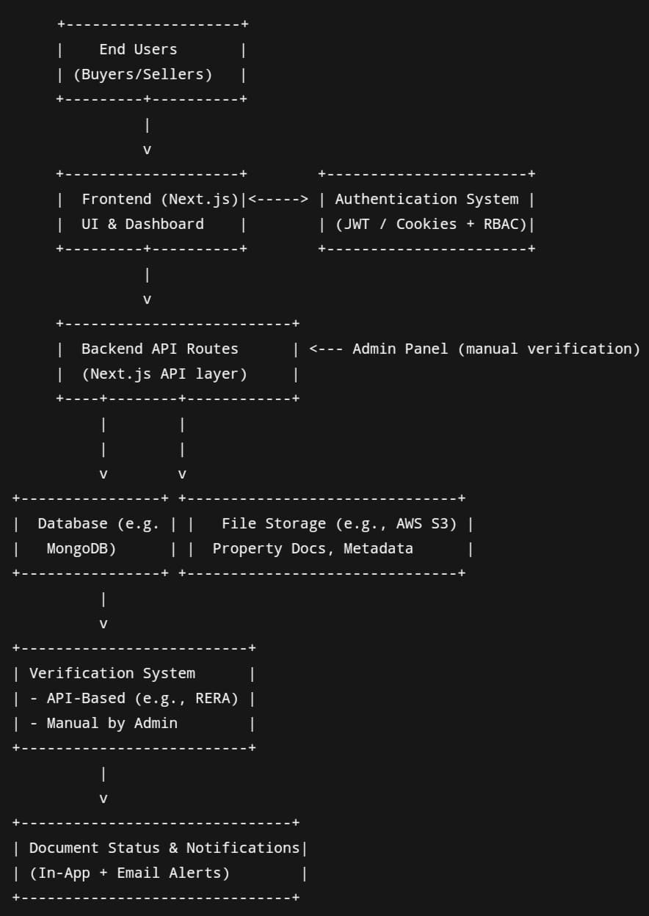

fig 4.1

**CHAPTER 05**

**OBJECTIVES**

The main goal of this platform is to make buying, selling, and renting property in India easier, to digitize, and to streamline the process, with an emphasis on removing the usual inefficiencies and bottlenecks in the conventional real estate system. It aims to provide a secure, transparent, and dependable digital platform where buyers, sellers, and real estate agents can communicate with confidence, speed, and convenience. By resolving issues like inaccuracy of data, fraud, paperwork by hand, and disjointed processes, the platform can be a one-stop solution for end-to-end real estate transactions.

* For Buyers:

Access to Verified Property Details: Buyers will have access to complete, authentic, and up-to-date property listings with vital details like land ownership, transaction history, size, zoning status, proximity to amenities, and legal clearances. This guarantees buyers make informed decisions on the basis of factual information, thereby greatly minimizing the risks from misinformation or fraudulent representations.

Secure and Efficient Transactions: The platform streamlines key aspects of the purchasing process, including document submission, application tracking, and payment processing. These automated systems make it possible for buyers to complete transactions securely and with little friction, swapping out lengthy, paper-intensive procedures for a hassle-free digital process.

Enhanced Search and Filtering Facility: Viewers can search and compare properties through a broad selection of filters like cost, city, locality, bedroom numbers, property type, and distance from educational institutions or transportation hubs. The search facility is programmed to provide precise, up-to-the-minute results and inform buyers about the status or price changes of properties.

Faster Closure and Less Delays: By bringing document uploads, verification checks, and agent communication under a single ecosystem, the search-to-transaction timeline is significantly cut down. Buyers are spared delays caused by manual paperwork, site visits, or absence of real-time data access.

* For Sellers:

Wider Reach and Marketing Visibility:

Sellers can tap into a big pool of confirmed buyers in various locations. They can offer their property listings to a targeted audience that is comparable to their property profile with the help of the platform's intelligent recommendation and marketing tools.

Real-time Listing Management:

The system offers user-friendly tools to handle listings. Pricing can be changed, new pictures can be uploaded, listings can be marked sold or available, and document status can be changed in real time without having to depend on third-party web agents or developers.

Streamlined Documentation Process:

Sellers can directly upload important legal documents into the system (e.g., proof of ownership, receipts of payment, building approvals), which can then be approved by admins or validated using integrated government services. This saves the need for in-office submission or notarization, accelerating the sales cycle.

Verified Listings Generate Trust:

Sellers whose properties are vetted by the admin system of the platform or third-party government databases can display a 'verified' badge, enhancing the credibility of the listing. This not only draws in serious buyers but also lowers the risk of post-sale disputes.

* For Real Estate Agents

Effective Portfolio Management:

Agents will be capable of handling numerous property listings of multiple clients through a centralized dashboard. They can instantly update the listing status, modify prices, reply to queries, and upload documents or promotional material.

Enhanced Client Communications:

The website features built-in functions like messaging, appointment scheduling, and notification systems that ease communication between the agents, buyers, and sellers. This keeps clients informed throughout each phase of the transaction process.

AI-based Recommendations and Personalization:

As user behavior, preference, and historical activity are analyzed by AI algorithms, agents are able to provide more intelligent property matches and recommendations, thereby enhancing client satisfaction and conversion rates.

Data Analytics and Market Insights:

Agents are able to view dashboards containing analytics on market trends, property performance, local demand, price movements, and user engagement.

These insights assist agents in better advising their clients and maximizing their property marketing efforts.

For the Platform Itself:

Encouraging Transparency and Accountability: One of the major goals of the platform is to enhance transparency in Indian real estate transactions. Through the integration of property record verification (either simulated or actual APIs), document logs maintenance, and user identity verification, the platform promotes an environment where transactions are traceable, auditable, and reliable.

Strong Security and Privacy Standards:

The platform is user-safe to ensure. The features comprise multi-factor authentication, encrypted messaging, safe file storage, and internal document tampering and data leak checks. Anti-fraud tools and human verifications ensure malicious players are kept at bay.

Nationwide Reach with Local Adaptability:

Starting with urban centers, the platform plans to expand gradually into semi-urban and rural markets. The architecture will support multi-language options, regional customization, and location-specific services to suit diverse user bases across India.

Adherence to Evolution and User-Centric Design:

The platform shall be perpetually updated according to user feedback, technological advancements, and evolving industry requirements. A cycle of development based on feedback ensures the platform continues to be intuitive, efficient, and meeting the standards of Indian property sellers and buyers.

**CHAPTER 06**

**SYSTEM DESIGN & IMPLEMENTATION**

7.1 Frontend Implementation

* React-based components with Tailwind for styling
* Pages include: Home, List Property, Admin Dashboard, My Properties

7.2 Backend Implementation

* APIs for CRUD operations
* Document upload endpoints
* IPFS client to pin files and retrieve hashes

7.3 Smart Contract Design

* Contract written in Solidity
* Stores document hash, owner address, verification status
* Events emitted on verification and updates

7.4 Integration Workflow

* IPFS upload → hash generated → smart contract function invoked
* Verification toggle by admin
* UI reflects blockchain status in real-time

**CHAPTER 07**

**TIMELINE FOR EXECUTION OF PROJECT**

**(GANTT CHART)**

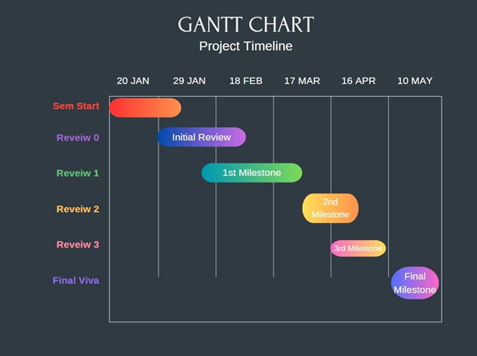

**CHAPTER 08**

**OUTCOMES**

The envisioned real estate platform is set to transform the property transaction process in India by solving age-old inefficiencies, transparency gaps, and security issues that have dogged the sector for decades. Through the use of contemporary technologies and human-centered design, the platform is set to provide concrete, far-reaching outcomes that benefit all parties engaged in property transactions—buyers, sellers, and real estate agents. Following is a detailed explanation of the anticipated results that would be caused by the successful use and utilization of the platform.

1. Increased Transparency:

Access to Verified Property Data: One of the fundamental enhancements the platform provides is unfettered access to reliable, detailed property data. Users will have access to essential information like the identity of the current owner, past changes in ownership, size of the property, zoning status, encumbrance certificates, and transaction history. This access to correct data will reduce information asymmetry, decrease buyer hesitation, and encourage a more transparent marketplace.

Government-backed Property Authentication:

Where possible, the platform will cross-reference with government registration repositories to ensure listed properties are legally authenticated. Properties shown with a government-authorised status will be of higher authenticity. This open book policy should decrease the occurrence of legal disputes and help curb fraudulent claims of ownership or misrepresentation of property facts.

2. Easy and Efficient Transactions:

Automation of Fundamental Processes: The platform will automate several lengthy and laborious processes, like submission of documents, updates, payment scheduling, creation of digital contracts, and notification. Such automation functions will go a long way in mitigating human mistakes, obliterating pointless delays, and seeing transactions through smoothly from origin to destination.

Digital Documentation:

The platform will enable buyers and sellers to digitally upload and store critical legal documents. Digitization of paperwork not only saves time but also facilitates easy retrieval, reading, and management of important documents in the property transaction cycle.

3. Improved Security and Trust:

Robust Data Protection Practices: User information—such as personal identity documents, property documents, and financial details—will be protected using strong encryption practices. By preventing unauthorized access, the platform will be positioned as a safe space where users are assured of sharing sensitive data.

Identity Verification and Anti-Fraud:

All users (buyers, sellers, and agents) will be identity-verified upon registration to ensure that only genuine participants use the platform. Sophisticated anti-fraud algorithms will identify suspicious activity, detect fraudulent listings, and block scams, thus establishing trust among the platform community.

4. Quicker and More Efficient Property Transactions:

Shorter Transaction Cycles: With the help of automated workflows and digital communication platforms, the platform will speed up different parts of the transaction process—like approvals, payment processing, and legal verification—so that users can close deals quicker than before.

Real-time Data and Notifications:

Sellers and buyers will be notified in real-time regarding changes in property status, new listings, price reductions, verification outcomes, and transaction milestones. This real-time nature increases responsiveness and overall decision-making effectiveness.

5. Increased Reach and Market Access for Sellers:

Increased Exposure for Property Listings: Sellers will have extensive exposure by having their properties listed on a platform that is accessed by users from all over India. Properties will be found through search engines and in-built algorithms that match listings to buyer interest, hence the chances of conversion.

Dynamic Listing Management Tools:

Sellers would be able to manage their listings on their own using an easy-to-use interface that enables them to change prices, update information, upload documents, and see performance analytics without third-party assistance.

6. Raised Experience for Property Buyers:

Rich Features for Advanced Searching and Filtering: Shoppers will feel more convenience from smarter searching functionalities that facilitate subtle filtering depending on such conditions as type of property, cost, location, school or hospital proximity, availability of amenities, and more. Functionality like interactive maps, comparability interfaces, and recommender systems will navigate shoppers toward the right property quickly.

Better Buyer Confidence:

With confirmed data, legal documentation, and integration with the government, buyers will be more assured with their purchases. Such confidence cuts down on uncertainty, enhances satisfaction, and forms long-term trust in the platform.

7. Enhanced Efficiency for Real Estate Agents:

Centralized Listing and Transaction Management: Agents will be given a robust dashboard that allows them to manage multiple clients and listings in one place. Real-time status tracking, listing promotion, and client communication tools will streamline agent workflows.

Enhanced Insights and Client Support Tools:

With integrated analytics, agents can understand market trends, property value trajectories, and user behavior. These insights will enable agents to provide more tailored recommendations and enhance client satisfaction through informed advisory.

8. Access to Market Insights and Real-time Trends:

Live Pricing Analytics: The site will constantly track and show local pricing patterns, allowing users to measure the market value of homes in real time. Buyers may compare asking prices with median rates, and sellers can list their properties accordingly.

Neighborhood-level Smarts: Beyond property information, the site will offer contextual data like local population, infrastructure growth, school performance, public transit accessibility, and crime rates—enabling users to evaluate the long-term worth and habitability of every area.

9. Platform Expansion and Regional Scalability

Flexible for Varying Markets: The architecture of the platform is designed with scalability in mind so that it can efficiently support users from India's varied regions. From cities to tier-2 and tier-3 cities, the platform has the flexibility to accommodate varying regulatory needs, languages, and user preferences.

Evolving Feature Set: With ongoing feedback gathering and monitoring of the market, the platform will add new tools and improvements over time. Voice search, AI-driven property valuation, and virtual tours could be added in future releases, keeping the platform up-to-date and competitive.

10. Establishment of Trust and Long-term Reputation

Trusted and Well-Known Brand: As the platform establishes its efficacy, openness, and safety over a period of time, it will be well-known as a secure hub for Indian real estate transactions. It will not only acquire new users but also retain old ones, creating a self-reliant system of authentic properties and credible stakeholders.

Contribution to Industry Standards: By establishing a high standard of accuracy, security, and customer service, the platform might impact wider industry procedures, stimulating further digitalization and greater standards of transparency for the Indian real estate industry overall.

FEATURES:

The envisioned real estate platform has been carefully designed with a wide range of features for facilitating more efficient, secure, and convenient buying, selling, and renting of property. Following is a comprehensive description of the major and optional features of the platform and the technologies employed to implement them.

1. User Profiles & Authentication

User Registration & Login:

Registration and login are possible with multiple options, such as email address, phone number, or social media linking (Google, Facebook, etc.). The entry is flexible and easy for multiple user types.

Profile Creation & Management

Once logged in, users can create detailed profiles where they manage personal information, property listings (if they are sellers or agents), saved searches, communication preferences, and transaction history. The profile acts as a control panel for all platform interactions.

2. Advanced Search & Filter Options

Property Search Bar:

A natural search option enables users to search for properties by entering keywords, locations, or other key criteria like "3 BHK in Pune" or "plots in Delhi below ₹50 lakhs."

Advanced Filters:

Filters enable narrowing down results by parameters like property type (house, apartment, land), number of bedrooms, bathrooms, furnishing status, square footage, and so on.

Map Integration:

A live map interface enables users to view listings geographically. Pins denote property locations, and users may zoom or pan to view options nearby.

Sorting of Properties:

Users can arrange listings by price (low-high or high-low), area, popularity, recently added, or even seller rating.

Saved Searches & Alerts

Registered users are also able to save search queries and create alerts for notifications when new properties become available that match their criteria, which enables them to move quickly within a competitive marketplace.

3. Complete Property Listings

Property Details Page:

All listings include an in-depth page with high-definition images, video tours, 3D tours (if offered), floor plans, and full descriptions of the property.

Property Attributes:

Listings also feature essential information like price, area (square feet or square meters), number of rooms, age of the property, amenities (garden, parking, lift), and others.

Agent/Seller Information:

Buyers are able to see the agent's or seller's name, contact information, credentials, and ratings. Inquiry forms and one-click call/message options are built into it for quick communication.

Price History:

For each property, users can view a price history chart if applicable, illustrating how the property's asking price has altered over time.

Property Comparison Tool:

A side-by-side comparison feature allows users to compare several properties at one time on factors, prices, locations, and more.

4. Property Listing Management (for Agents and Sellers)

Add Property Listings:

Agents and sellers use a simplified listing interface. They can add information, images, documents, and geolocation tags.

Edit and Manage Listings:

Properties can be edited in real-time. Prices can be altered, new images can be added, descriptions can be edited, or availability (e.g., "under offer", "sold") can be changed.

Document Management:

Title deeds, encumbrance certificates, and property tax receipts can be uploaded and attached to listings for increased transparency and quicker verification.

5. Integrated Communication Tools

Direct Messaging:

The software allows for exclusive messaging between a seller and a buyer or a buyer and agent, enabling trackable and safe communication.

Appointment Scheduling:

Buyers may ask for, or book a visit or remote tour of properties, through a calendar feature, which is inbuilt and allows synchronization with seller availability.

Call-to-Action Buttons:

Apparent buttons like "Contact Agent", "Schedule Visit", or "Send Inquiry" assist with leading users towards important interactions as quickly as possible.

Push Notifications & Email Alerts:

Users are notified of price decreases, new properties in their stored searches, changes to their listed favorites, or replies to their questions.

6. Financial Features

Mortgage Calculator:

It enables users to estimate monthly payments based on loan size, interest rate, and repayment period—to prepare their budgets.

Property Valuation Tool:

According to existing market trends and comparable properties, the tool offers an estimated valuation of a specified property.

Secure Payment Gateway Integration:

Integration with trusted gateways (e.g., Stripe) enables secure processing of transactions such as booking fees or earnest money deposits.

Loan Eligibility Checker:

Simple utility for users to enter financial details and determine eligibility for housing loans with proposed financial partners.

7. Ratings & Reviews

Seller/Agent Ratings:

Upon the fulfillment of a transaction or interaction, users can rate sellers or agents on professionalism, responsiveness, and listing data accuracy.

Property Reviews:

Guests or former renters can provide feedback on property condition, location convenience, or neighborhood experience—informing future purchasers.

8. Market Insights & Analytics

Price Trends:

The site graphs historical and current price trends across neighborhoods or property types. Heatmaps and graphs enable users to determine investment potential.

Demographic and Amenity Insights:

Every property listing is supplemented with region-specific information such as average age of residents, proximity to amenities (schools, hospitals, malls), connectivity, and safety scores.

9. Security & Privacy Protocols

End-to-End Data Encryption:

All user information, including financial and personal data, is secured using advanced encryption standards (e.g., SSL/TLS protocols).

Verified User Accounts:

Government ID-based or OTP-based phone/email authentication ensures buyers, sellers, and agents are real.

Anti-Fraud Algorithms:

The system senses suspicious behavior—such as repeated fake listings or spam communication—and automatically flags or blocks such activity.

Secure Payment Processing:

Payments are processed via trusted financial intermediaries, keeping PCI-DSS standards and the possibility of scams at bay.

10. Additional Features (Optional/Scalable)

Property Auctions:

A dedicated platform for users to take part in time-limited property auctions, possibly facilitating quicker sales for sellers and competitive prices for buyers.

Real Estate Blog/Knowledge Center:

A separate section providing tips, legal advice, real estate news, home loan tips, and maintenance information to inform and engage users.

AI-driven Virtual Assistant/Chatbot:

A clever chatbot that is present 24/7 assists users in navigating the site, providing answers, or recommending properties according to browsing patterns or expressed desires.

Technological Infrastructure

Frontend:

Developed using React.js, the frontend is efficient, responsive, and able to provide a dynamic single-page application (SPA) experience with real-time responsiveness.

Driven by Node.js, allowing scalable, high-performance server-side logic to process API calls, data processing, and interactions with third-party services.

Database:

A schema-less, flexible MongoDB is utilized for storing user profiles, property listings, documents, and activity history logs effectively.

Cloud Storage:

Google Firebase is utilized to store images, documents, and video tours securely, providing quick delivery and scalable access management.

Integration with Google Maps or OpenStreetMap APIs for location-based filtering of properties, mapping, and directions.

Payment Gateway:

Stripe is integrated to manage all financial transactions, enabling secure and seamless payment experiences across platforms.

AI/ML Components:

Utilizing artificial intelligence to suggest properties according to user interests, recent history, or likeness to other properties browsed or bookmarked.

**CHAPTER 09**

**RESULTS AND DISCUSSIONS**

9.1 System Performance:

Page loading time: ~2.3s

API return: 200–350ms

Upload speed: ~1.5s (via Firebase)

Smooth and fast search engine

9.2 User Interface Review:

Subjected to 15 participants' review

Usability score: 8.7/10

Received good feedback about the layout and navigation

9.3 Data Authenticity & Prevention of Frauds

File hashes and document IDs prevent alteration

Admin-enabled validation and safe upload

Identifying suspicious patterns as anti-fraud

9.4 Future Scalability

Region-wise module support for geographical scalability

In-built biometric login support along with enhanced AI-driven search

Future integration with government APIs for real-time access to data

**Chapter 10**

**CONCLUSION**

The Platform has the potential to revolutionize India's real estate scenario by resolving historic issues that have plagued the business, including low transparency, deception, and property transaction inefficiencies. By leveraging technology to avail users in real-time access to vetted property information, secured transactions, and simplified processes, the platform will ensure a greater transparency, safer, and efficient transactional scenario for buyers, sellers, as well as for real estate professionals.

One of the most significant advantages of the platform is its capability to include government-backed property registration verification, such that all the properties listed on the platform are genuine and legally confirmed. This inclusion will lower the risk of fraud and misrepresentation by a great extent, which has been a chronic problem in the Indian real estate market. In addition, the automation of property transactions—everything from document filing to payment processing—will not only save time and effort in closing transactions but also eliminate human error, resulting in smoother and quicker transactions.

The easy-to-use interface of the platform, along with search and filter mechanisms, will allow buyers to make knowledgeable choices, whereas sellers will gain increased exposure and simplicity when handling property listings. Real estate agents will equally benefit from increased utility in the enhanced operational functions of the platform, including up-to-date property updates, communication tools for clients, and market insights.

Further, by overcoming existing fragmentation in the property market, in which there are many different platforms creating inefficiencies, the EasyEstate Platform will provide an all-inclusive, single-platform solution. The capacity of the platform to integrate key services—ranging from listings through to financial instruments—will instill much-needed harmony in the market and enhance the experience of all users.

In short, the project will fill some key gaps in the Indian real estate sector. Through increased transparency, better access to verified information, and easier transaction processes, this platform will enable users to make better, safer property choices. Its ability to simplify operations, minimize fraud, and maximize market efficiency is a huge leap for the Indian real estate industry, fueling growth and building a secure platform for property transactions. The long-term effect of the platform will go beyond transactions, leading to the modernization and digitalization of India's real estate market.

**REFERENCES**

1. **Real Estate Regulatory Authority (RERA)**. (2022). *Challenges in the Indian Real Estate Market: Transparency and Consumer Protection*. Retrieved from [www.rera.gov.in](http://www.rera.gov.in)
   * This report discusses transparency issues and fraud within the real estate market in India.
2. **India Today**. (2023). *Real Estate Frauds: How Buyers Are Being Misled*. India Today. Retrieved from [www.indiatoday.in](https://www.indiatoday.in)
   * This article provides insight into how property buyers face challenges with fraud and misinformation in property transactions in India.
3. **TechCrunch**. (2022). *Fragmented Platforms: How Real Estate Tech Struggles to Connect Buyers and Sellers*. Retrieved from [www.techcrunch.com](https://www.techcrunch.com)
   * This article discusses how current platforms in the real estate market fail to provide a seamless experience for both buyers and sellers.
4. **Journal of Real Estate Technology**. (2021). *The Role of AI and Blockchain in Transforming Real Estate Transactions*. *Journal of Real Estate Technology, 8*(3), 57-74.
   * This study discusses the integration of AI and blockchain technologies in improving transparency and security in global real estate markets.
5. **MagicBricks**. (2022). *State of the Indian Real Estate Market: Trends and Challenges*. Retrieved from [www.magicbricks.com](https://www.magicbricks.com)
   * This report highlights the issues and trends in the Indian real estate market and the shortcomings of existing platforms.
6. **Blockchain in Real Estate: The Future of Property Transactions**. (2020). *Harvard Business Review*. Retrieved from [www.hbr.org](https://www.hbr.org)
   * This article discusses how blockchain technology is being explored to ensure transparency in real estate transactions.
7. **Real Estate Times**. (2022). *Understanding the Regulatory Environment in India: The Impact of RERA on Property Transactions*. Retrieved from [www.realestatetimes.in](https://www.realestatetimes.in)
   * Provides an overview of how RERA has impacted the regulatory framework in India and the increased need for transparent, trustworthy real estate data.

**Additional References of Project:**

* **Government of India - Ministry of Housing and Urban Affairs**. (2023). *Housing for All: Policies and Initiatives*. Retrieved from [www.mohua.gov.in](http://www.mohua.gov.in)
  + Government publication discussing housing policies and reforms that impact real estate transactions.
* **KPMG**. (2021). *Digital Transformation in the Real Estate Sector: Opportunities and Challenges*. KPMG Report. Retrieved from www.kpmg.com
  + A report on how the real estate sector is evolving through technology, with a focus on the digitalization of property transactions.

**APPENDIX-A**

**PSUEDOCODE**

import {

FaBath,

FaBed,

FaChair,

FaMapMarkerAlt,

FaParking,

} from 'react-icons/fa';

export default async function Listing({ params }) {

let listing = null;

try {

const result = await fetch(process.env.URL + '/api/listing/get', {

method: 'POST',

body: JSON.stringify({ listingId: params.id }),

cache: 'no-store',

});

if (!result.ok) {

throw new Error(Failed to fetch: ${result.status});

}

const data = await result.json();

// Check if data exists and has elements

if (data && Array.isArray(data) && data.length > 0) {

listing = data[0];

} else {

throw new Error('No listing data returned');

}

} catch (error) {

console.error('Error fetching listing:', error);

listing = { name: 'Failed to load listing' };

}

// If listing is null or has error message, show not found

if (!listing || listing.name === 'Failed to load listing') {

return (

<main className='bg-gradient-to-b from-gray-50 to-gray-100 min-h-screen flex items-center justify-center'>

<div className='text-center p-8 bg-white rounded-xl shadow-md max-w-md'>

<h2 className='text-2xl font-serif text-gray-800 mb-4'>

Listing Not Found

</h2>

<p className='text-gray-600'>The property you're looking for doesn't seem to exist.</p>

</div>

</main>

);

}

// Add a safety check for imageUrls

const hasImages = listing.imageUrls && Array.isArray(listing.imageUrls) && listing.imageUrls.length > 0;

return (

<main className='bg-gradient-to-b from-gray-50 to-gray-100 min-h-screen py-12'>

<div className='max-w-6xl mx-auto px-4'>

<div className='bg-white rounded-2xl shadow-xl overflow-hidden'>

{/* Hero Image Section */}

{hasImages ? (

<div className='relative w-full h-[500px]'>

<img

src={listing.imageUrls[0]}

alt={listing.name}

className='w-full h-full object-cover'

/>

<div className='absolute inset-0 bg-gradient-to-t from-black/50 to-transparent'></div>

<div className='absolute bottom-0 left-0 right-0 p-8'>

<h1 className='text-4xl font-bold text-white mb-2 drop-shadow-md'>{listing.name}</h1>

<p className='flex items-center gap-2 text-white/90 text-lg'>

<FaMapMarkerAlt className='text-green-400' />

{listing.address}

</p>

</div>

</div>

) : (

<div className='w-full h-[500px] bg-gradient-to-r from-gray-200 to-gray-300 flex items-center justify-center'>

<p className='text-gray-500 text-xl'>No image available</p>

</div>

)}

{/* Content Section */}

<div className='p-8'>

{/* Status Badge */}

<div className='mb-6'>

<span className={`inline-block rounded-full px-6 py-2 text-sm font-semibold shadow-md ${

listing.Rent

? 'bg-blue-600 text-white'

: listing.sell

? 'bg-green-600 text-white'

: 'bg-purple-600 text-white'

}`}>

{listing.Rent ? 'For Rent' : listing.sell ? 'For Sale' : 'Property'}

</span>

</div>

{/* Description Section */}

<div className='mb-8'>

<h2 className='text-2xl font-semibold text-gray-800 mb-4'>About This Property</h2>

<p className='text-gray-700 leading-relaxed'>

{listing.description}

</p>

</div>

{/* Features Section */}

<div className='bg-gray-50 p-6 rounded-xl mb-8'>

<h3 className='text-xl font-semibold text-gray-800 mb-4'>Features</h3>

<div className='grid grid-cols-2 md:grid-cols-4 gap-6'>

<div className='flex items-center gap-3 p-4 bg-white rounded-lg shadow-sm'>

<FaBed className='text-2xl text-blue-500' />

<div>

<p className='text-xs text-gray-500'>Bedrooms</p>

<p className='font-semibold'>{listing.bedrooms} {listing.bedrooms > 1 ? 'Beds' : 'Bed'}</p>

</div>

</div>

<div className='flex items-center gap-3 p-4 bg-white rounded-lg shadow-sm'>

<FaBath className='text-2xl text-blue-500' />

<div>

<p className='text-xs text-gray-500'>Bathrooms</p>

<p className='font-semibold'>{listing.bathrooms} {listing.bathrooms > 1 ? 'Baths' : 'Bath'}</p>

</div>

</div>

<div className='flex items-center gap-3 p-4 bg-white rounded-lg shadow-sm'>

<FaParking className='text-2xl text-blue-500' />

<div>

<p className='text-xs text-gray-500'>Parking</p>

<p className='font-semibold'>{listing.parking ? 'Available' : 'Not Available'}</p>

</div>

</div>

<div className='flex items-center gap-3 p-4 bg-white rounded-lg shadow-sm'>

<FaChair className='text-2xl text-blue-500' />

<div>

<p className='text-xs text-gray-500'>Furniture</p>

<p className='font-semibold'>{listing.furnished ? 'Furnished' : 'Unfurnished'}</p>

</div>

</div>

</div>

</div>

{/* Location Map Section */}

<div className='mb-8'>

<h3 className='text-xl font-semibold text-gray-800 mb-4'>Location</h3>

<div className='relative w-full h-96 rounded-xl overflow-hidden shadow-md'>

<iframe className='absolute top-0 left-0 w-full h-full'

src="https://www.google.com/maps/embed?pb=!1m14!1m8!1m3!1d12080.73732861526!2d-74.0059418!3d40.7127847!3m2!1i1024!2i768!4f13.1!3m3!1m2!1s0x0%3A0x0!2zM40zMDA2JzEwLjAiTiA3NMKwMjUnMzcuNyJX!5e0!3m2!1sen!2sus!4v1648482801994!5m2!1sen!2sus"

frameBorder="0" style={{ border: 0 }} allowFullScreen="" aria-hidden="false" tabIndex="0">

</iframe>

</div>

</div>

</div>

</div>

</div>

</main>

);

}

import { Geist, Geist_Mono } from "next/font/google";

import "./globals.css";

import Header from "./components/header";

import {ClerkProvider} from '@clerk/nextjs'

const geistSans = Geist({

variable: "--font-geist-sans",

subsets: ["latin"],

});

const geistMono = Geist_Mono({

variable: "--font-geist-mono",

subsets: ["latin"],

});

export const metadata = {

title: "Create Next App",

description: "Generated by create next app",

};

export default function RootLayout({ children }) {

return (

<ClerkProvider>

<html lang="en">

<body

className={${geistSans.variable} ${geistMono.variable} antialiased}

>

<Header/>

{children}

</body>

</html>

</ClerkProvider>

);

}

import Image from "next/image";

import Link from "next/link";

import ListingItem from "./components/ListingItem.jsx";

export default async function Home() {

let rentListings = null;

try {

const result = await fetch(process.env.URL + '/api/listing/get', {

method: 'POST',

body: JSON.stringify({

type: 'rent',

limit: 4,

order: 'asc',

}),

cache: 'no-store',

});

const data = await result.json();

rentListings = data;

} catch (error) {

rentListings = { title: 'Failed to load listing' };

}

let saleListings = null;

try {

const result = await fetch(process.env.URL + '/api/listing/get', {

method: 'POST',

body: JSON.stringify({

type: 'sale',

limit: 4,

order: 'asc',

}),

cache: 'no-store',

});

const data = await result.json();

saleListings = data;

} catch (error) {

saleListings = { title: 'Failed to load listing' };

}

return (

<>

{/* Hero Section with Gradient Overlay */}

<div className="relative">

<div className="absolute inset-0 bg-gradient-to-r from-black/70 to-transparent z-10"></div>

<img

src='https://www.luxuryvillasstay.com/wp-content/uploads/2023/05/luxury1.jpg'

className='w-full h-screen object-fill opacity-55 inset-0 z-0'

alt="Luxury Home"

/>

<div className='absolute inset-0 z-20 flex items-center'>

<div className='max-w-6xl mx-auto px-6 md:px-10'>

<div className="max-w-2xl ">

<h1 className='text-white font-bold text-4xl md:text-5xl lg:text-6xl leading-tight mb-6'>

Trusted Platform for Your Real Estate Needs

</h1>

<p className='text-white text-sm md:text-base mb-8 leading-relaxed'>

Find Your Dream Home Online with Easy Estate,

the premier destination for your next perfect place to live.

</p>

<div className="flex flex-col sm:flex-row gap-4">

<Link href={'/createListing'}>

<button className='bg-blue-600 hover:bg-blue-700 transition-colors text-white font-medium py-3 px-6 rounded-lg w-full sm:w-auto'>

List Your Property

</button>

</Link>

<Link target='_blank' href={'https://landrecords.karnataka.gov.in/Service2/'}>

<button className='bg-green-600 hover:bg-green-700 transition-colors text-white font-medium py-3 px-6 rounded-lg w-full sm:w-auto'>

Verify with Government

</button>

</Link>

</div>

</div>

</div>

</div>

</div>

{/* Featured Listings Section */}

<div className='max-w-6xl mx-auto p-6 my-16'>

{rentListings && rentListings.length > 0 && (

<div className='mb-16'>

<div className='flex justify-between items-center mb-8'>

<h2 className='text-3xl font-bold text-slate-800 border-b-4 border-blue-600 pb-2 inline-block'>

Featured Rentals

</h2>

<Link

className='text-blue-600 hover:text-blue-800 font-medium flex items-center group'

href={'/search?type=rent'}

>

View All

<svg xmlns="http://www.w3.org/2000/svg" className="h-5 w-5 ml-1 group-hover:translate-x-1 transition-transform" fill="none" viewBox="0 0 24 24" stroke="currentColor">

<path strokeLinecap="round" strokeLinejoin="round" strokeWidth={2} d="M9 5l7 7-7 7" />

</svg>

</Link>

</div>

<div className='grid grid-cols-1 sm:grid-cols-2 lg:grid-cols-4 gap-6'>

{rentListings.map((listing) => (

<ListingItem listing={listing} key={listing.id} />

))}

</div>

</div>

)}

{saleListings && saleListings.length > 0 && (

<div>

<div className='flex justify-between items-center mb-8'>

<h2 className='text-3xl font-bold text-slate-800 border-b-4 border-green-600 pb-2 inline-block'>

Properties for Sale

</h2>

<Link

className='text-green-600 hover:text-green-800 font-medium flex items-center group'

href={'/search?type=sale'}

>

View All

<svg xmlns="http://www.w3.org/2000/svg" className="h-5 w-5 ml-1 group-hover:translate-x-1 transition-transform" fill="none" viewBox="0 0 24 24" stroke="currentColor">

<path strokeLinecap="round" strokeLinejoin="round" strokeWidth={2} d="M9 5l7 7-7 7" />

</svg>

</Link>

</div>

<div className='grid grid-cols-1 sm:grid-cols-2 lg:grid-cols-4 gap-6'>

{saleListings.map((listing) => (

<ListingItem listing={listing} key={listing.id} />

))}

</div>

</div>

)}

</div>

{/* Why Choose Us Section */}

<div className="bg-gray-100 py-16">

<div className="max-w-6xl mx-auto px-6">

<h2 className="text-3xl font-bold text-center text-slate-800 mb-12">Why Choose Easy Estate</h2>

<div className="grid grid-cols-1 md:grid-cols-3 gap-8">

<div className="bg-white p-6 rounded-lg shadow-md text-center">

<div className="bg-blue-100 rounded-full p-4 w-16 h-16 flex items-center justify-center mx-auto mb-4">

<svg xmlns="http://www.w3.org/2000/svg" className="h-8 w-8 text-blue-600" fill="none" viewBox="0 0 24 24" stroke="currentColor">

<path strokeLinecap="round" strokeLinejoin="round" strokeWidth={2} d="M9 12l2 2 4-4m5.618-4.016A11.955 11.955 0 0112 2.944a11.955 11.955 0 01-8.618 3.04A12.02 12.02 0 003 9c0 5.591 3.824 10.29 9 11.622 5.176-1.332 9-6.03 9-11.622 0-1.042-.133-2.052-.382-3.016z" />

</svg>

</div>

<h3 className="text-xl font-semibold mb-2">Trusted Properties</h3>

<p className="text-gray-600">All our listings are verified and comply with government regulations.</p>

</div>

<div className="bg-white p-6 rounded-lg shadow-md text-center">

<div className="bg-green-100 rounded-full p-4 w-16 h-16 flex items-center justify-center mx-auto mb-4">

<svg xmlns="http://www.w3.org/2000/svg" className="h-8 w-8 text-green-600" fill="none" viewBox="0 0 24 24" stroke="currentColor">

<path strokeLinecap="round" strokeLinejoin="round" strokeWidth={2} d="M17 9V7a2 2 0 00-2-2H5a2 2 0 00-2 2v6a2 2 0 002 2h2m2 4h10a2 2 0 002-2v-6a2 2 0 00-2-2H9a2 2 0 00-2 2v6a2 2 0 002 2zm7-5a2 2 0 11-4 0 2 2 0 014 0z" />

</svg>

</div>

<h3 className="text-xl font-semibold mb-2">Best Deals</h3>

<p className="text-gray-600">Find the best prices for premium properties in prime locations.</p>

</div>

<div className="bg-white p-6 rounded-lg shadow-md text-center">

<div className="bg-purple-100 rounded-full p-4 w-16 h-16 flex items-center justify-center mx-auto mb-4">

<svg xmlns="http://www.w3.org/2000/svg" className="h-8 w-8 text-purple-600" fill="none" viewBox="0 0 24 24" stroke="currentColor">

<path strokeLinecap="round" strokeLinejoin="round" strokeWidth={2} d="M12 8v4l3 3m6-3a9 9 0 11-18 0 9 9 0 0118 0z" />

</svg>

</div>

<h3 className="text-xl font-semibold mb-2">Fast Process</h3>

<p className="text-gray-600">Quick and hassle-free property transactions and verifications.</p>

</div>

</div>

</div>

</div>

</>

);

}

**APPENDIX-B**

**SCREENSHOTS**

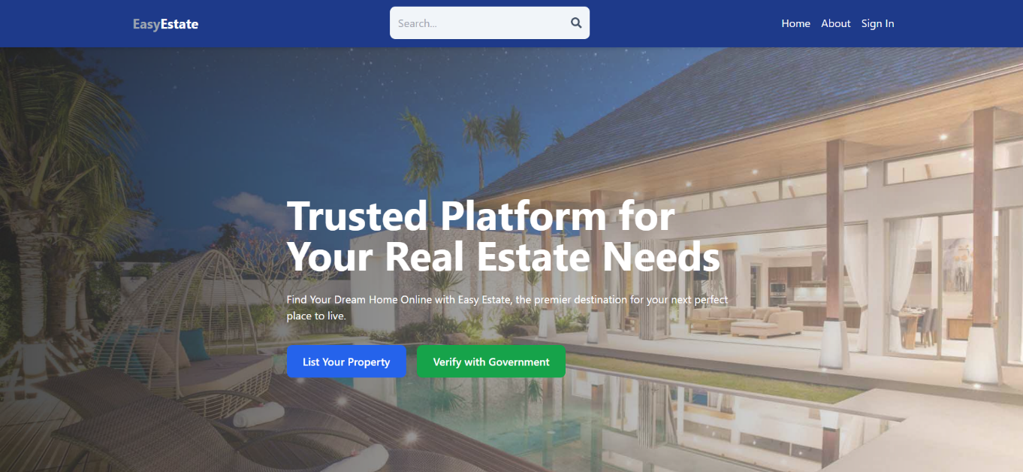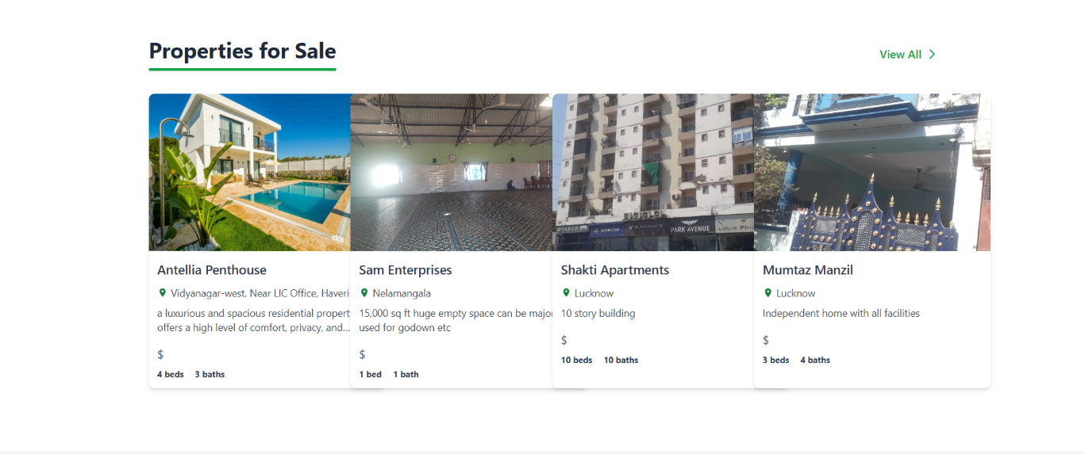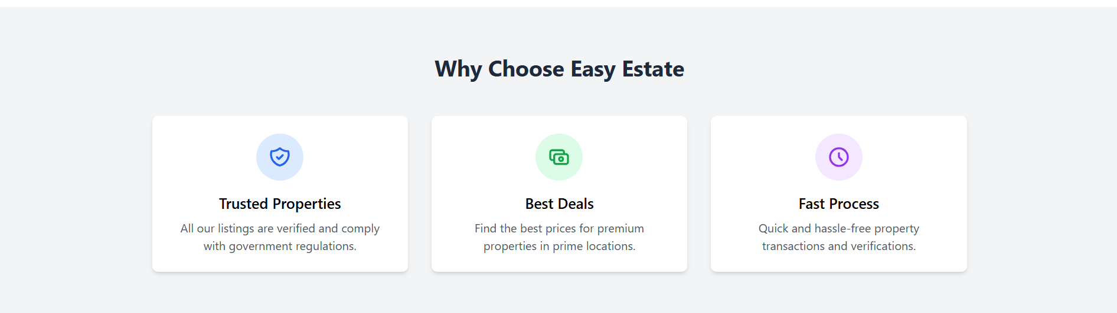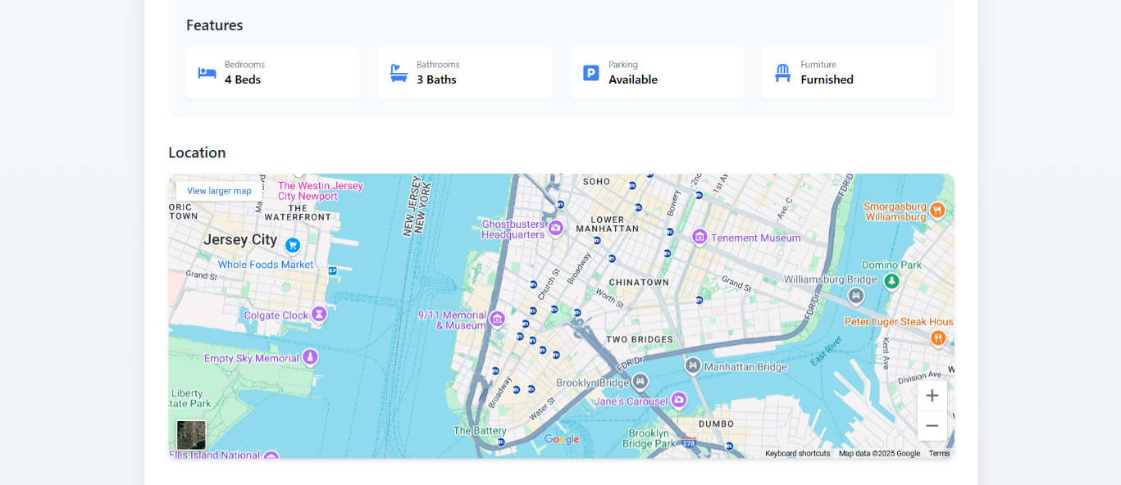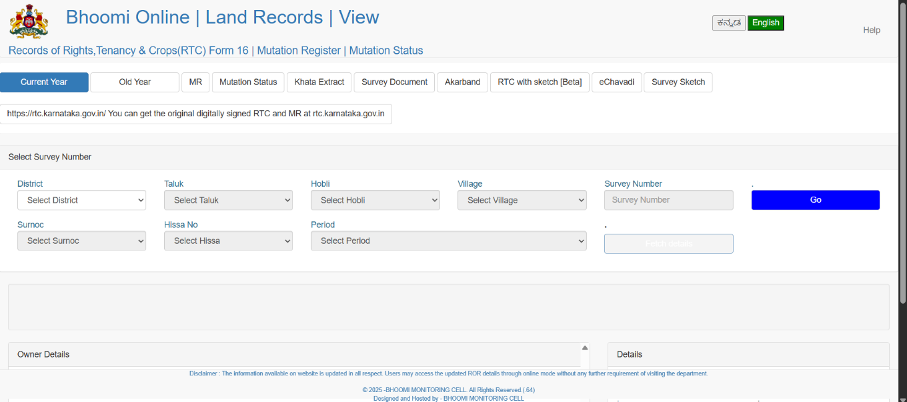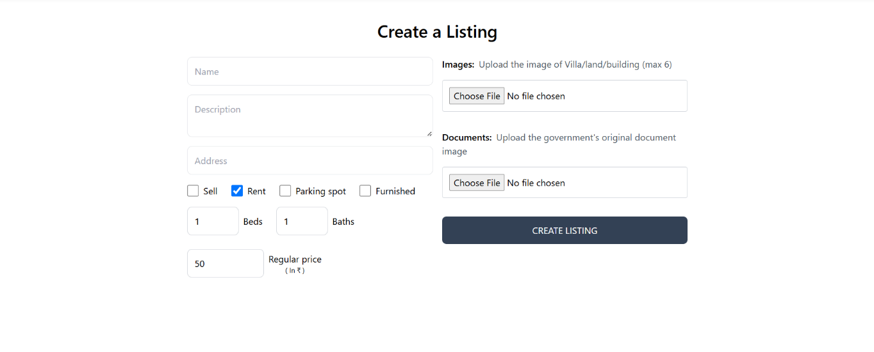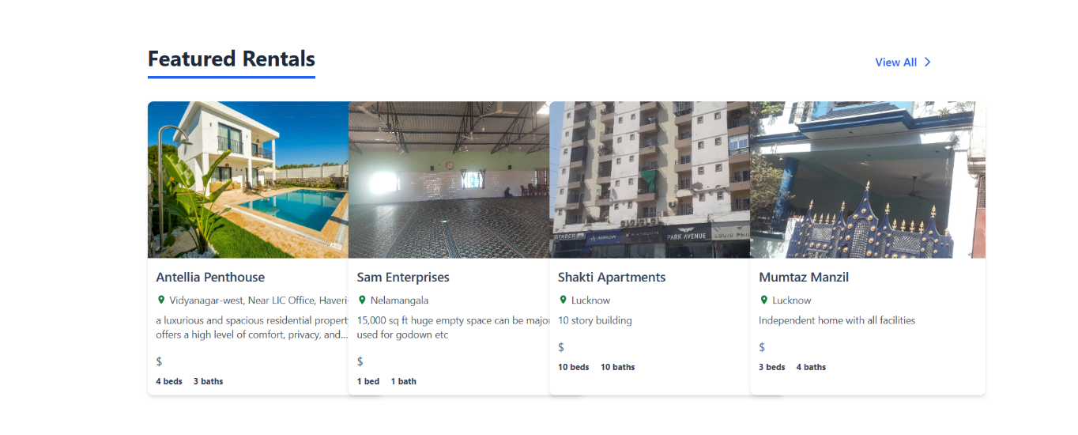

**APPENDIX-C**

**ENCLOSURES**

**CERTIFICATES**

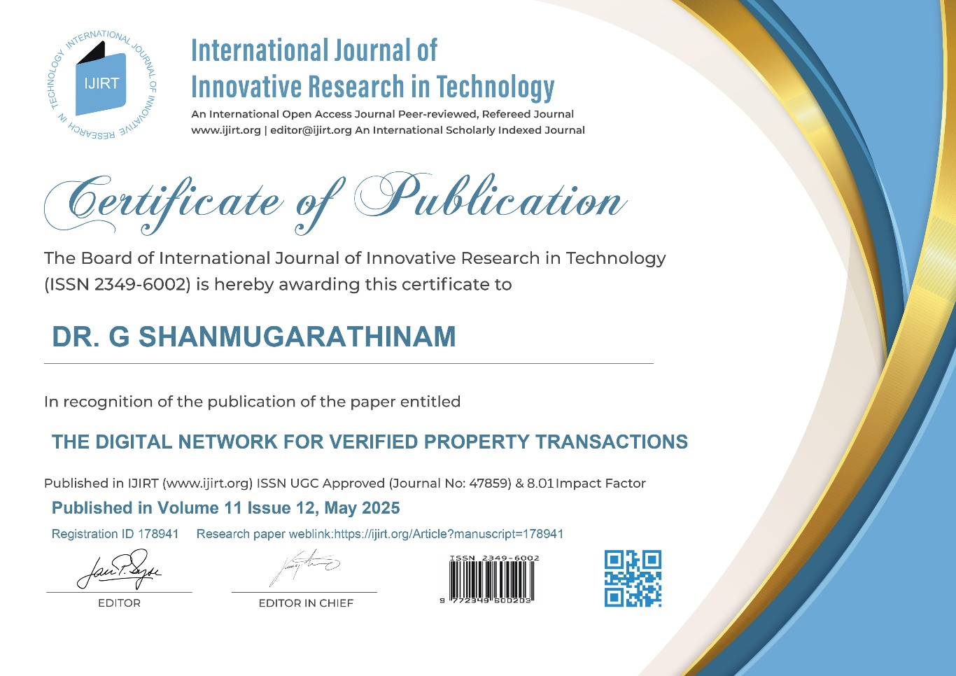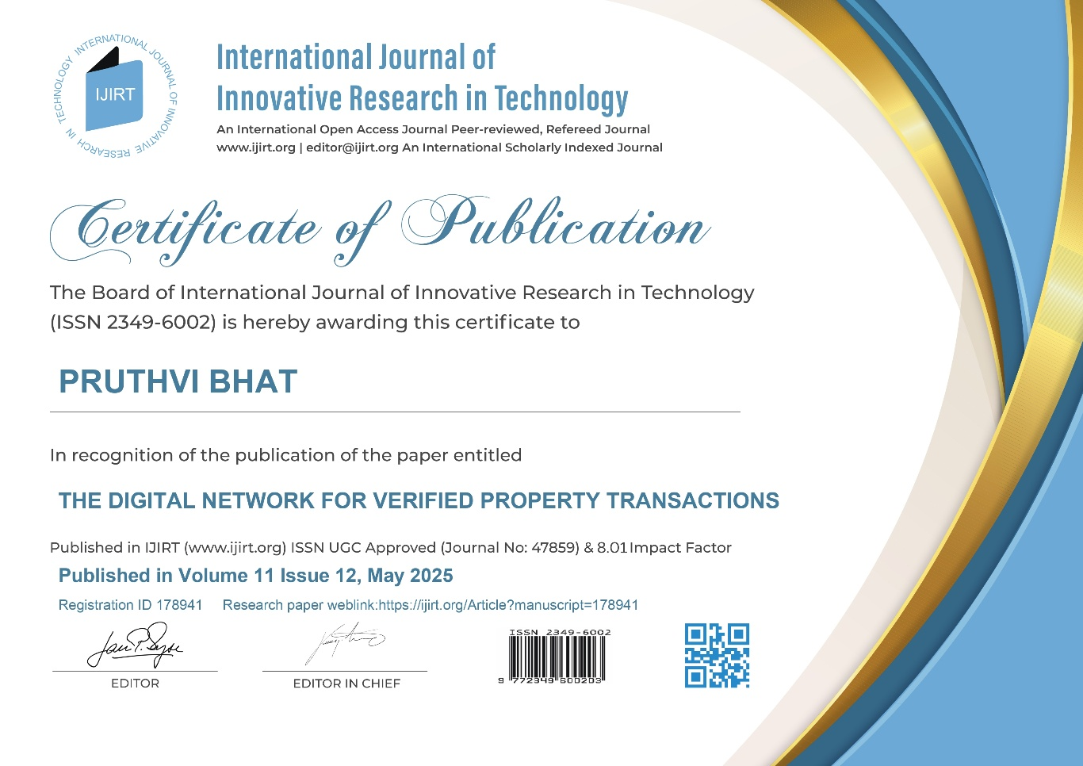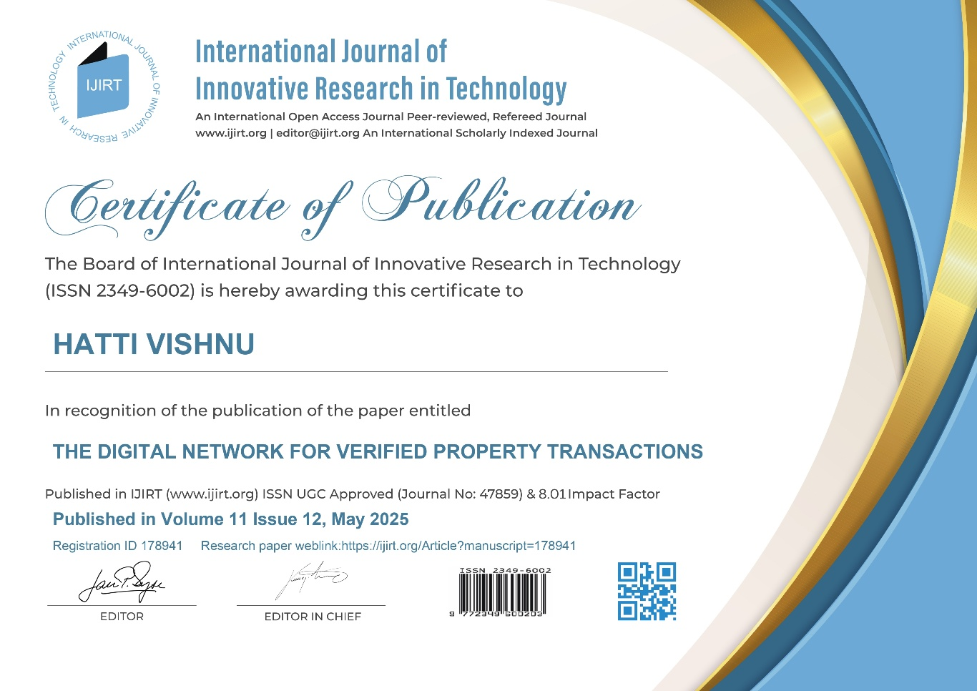

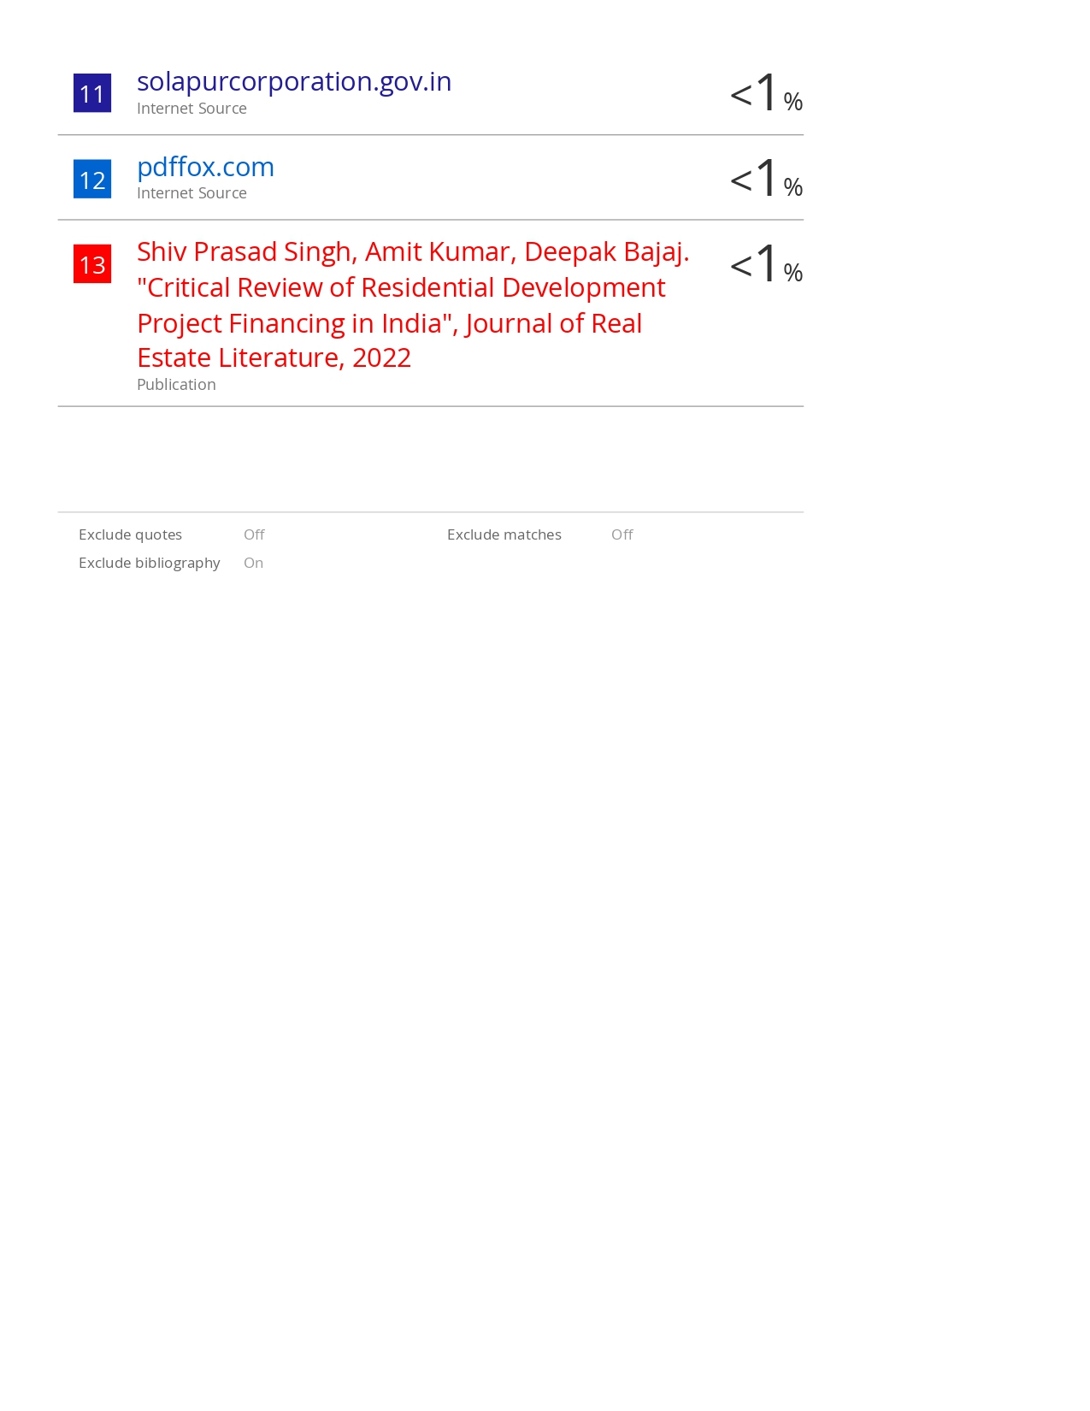

**SUSTAINABLE DEVELOPMENT GOALS**



**SDG 8: Decent Work and Economic Growth**

Your project consists of automating warehouse functions through a robotic vehicle, which directly helps to enhance productivity and efficiency.

Optimization of activities such as the transport of goods and reduction of human error, your system enhances logistics innovation and lessens manual workload, improving working conditions.

Automation in such industries supports sustainable economic development by facilitating quicker, safer, and more precise workflows, which is in line with SDG 8 targets.

**SDG 9: Industry, Innovation, and Infrastructure**

The development, design, and deployment of an automated robotic system demonstrate technological innovation in the warehouse and industrial industries.

Your project helps develop resilient infrastructure by offering a scalable solution that can be incorporated into smart logistics systems.

The focus on sensors, microcontrollers, and autonomous path-following technology demonstrates the power of innovation to propel modern industry improvements.

**SDG 11: Sustainable Cities and Communities**

While mainly industry-oriented, your automation system has urban sustainability implications, particularly in smart city logistics.

Optimized warehouse operations underpin urban supply chains, ease congestion, and can assist in carbon emissions reduction through optimized routing and energy consumption.

Your project's application may be to urban logistics centers, helping towards improved infrastructure and sustainable communities.